Results Summary Log

Motor ID | Time | Temp | Resist | Megohm | DA/PI | DC | Surge
CH-1 | 6/6/2016 11:33:58 AM | Tested | DELTA R | PASS | PASS | PASS | ppEAR LIMIT

Nameplate Information |  | Motor ID CH-1
Location | XYZ | Building | CUP
Model | 024-36776-441 | Manufacturer | RAM
Serial Number | W20003571 ML | HP/KW | 602
Volts-Rating | 460 | Volts-Operating | 480
Amps-Rating | 669 | Amps-Operating | 660
Insulation | F | Enclosure | N-ODP
RPM | 3577 | Service Factor | 1
Frame | 449TDZ | Freq-Hz | 60
LR Code | N/A | LR Amps | 4400
NEMA Design | N/A | Max Amb °C | 40
NEMA nom eff | 85 | Duty Cycle | CONT.
Manuf's Type | N/A | Manuf Dt Cd | N/A
Description | Chiller Motor  M/N:YKK3K4H9-LVGS  S/N:SAVM-

Application Information |  | Test Date/Time 6/6/2016 11:33:58 AM
Test ID | 480V w/RTR>101HP Step | Repair/Job # | 169298
Tested By | BVT | Tested For | Smith/XYZ
Room # | N/A | MCC | N/A
Location | CUP | Building | CUP
Use | Chiller | % Load | N/A
Vert/Horiz | Horizontal | Starter | VFD
Starts/24Hrs | N/A | Rewind Dt | N/A
Install Dt | N/A | Basic Dt | N/A
Volts 1 | 460.0 | Amps 1 | 0.0
Volts 2 | 460.0 | Amps 2 | 0.0
Volts 3 | 460.0 | Amps 3 | 0.0
Tester Type | AWA4 | Tester SN | 325
Tester ID | 99-A412-00E T-05-03 | PP30 SN | 0
Cal Date | 01/08/2018 | Next Cal Date | 01/07/2019

Results Summary |  | Test Date/Time 6/6/2016 11:33:58 AM
Test ID: | 480V w/RTR>101HP Step | Repair/Job # | 169298
Tested By | BVT | Tested For | Smith/XYZ
Room # | N/A | MCC | N/A
Location | CUP | Building | CUP
Temp Status | Tested | PI Status | PASS
Temp | 23.9°C 75.0°F | Volts (V) | 500
Resist Status | DELTA R | DA Ratio | 2.0
L1-L2 (Ohms) | 0.0076 Corr: 0.0077 | PI Ratio | 3.0
L2-L3 (Ohms) | 0.0082 Corr: 0.0082 | Step-Voltage | PASS
L3-L1 (Ohms) | 0.0076 Corr: 0.0076 | Volts (V) | 2000
Max Delta R % | 7.652 | I(µA) | 0.11
Coil 1 (Ohms) | 0.0112 Corr: 0.0112 | Resist (Mohm) | 18931 At 40°C 6196
Coil 2 (Ohms) | 0.0130 Corr: 0.0130 | Surge Status | ppEAR LIMIT
Coil 3 (Ohms) | 0.0111 Corr: 0.0112 | Peak Volt(V) L1 | 530 Failed
Megohm Status | PASS | Peak Volt(V) L2 | 740 Failed
Volts (V) | 500 | Peak Volt(V) L3 | 530 Failed
I(µA) | 0.04 | Max P-P EAR(%) | 16.7/5.1/6.1
Resist (Mohm) | 14085 At 40°C 4610 | EAR 1-2/2-3/3-1(%) | No Test

DA/PI |  | Motor ID CH-1
Test Date/Time | 6/6/2016 11:33:58 AM | Voltage (V) | 500
DA Ratio | 2.0 | PI Ratio | 3.0
PI Status | PASS

Time (Min) | I(µA) | Megohms
0:15 | 0.05 | 10000
0:30 | 0.04 | 12500
0:45 | 0.03 | 16666
1:00 | 0.03 | 16666
1:30 | 0.02 | 25000
2:00 | 0.02 | 25000
2:30 | 0.02 | 25000
3:00 | 0.02 | 25000
4:00 | 0.02 | 25000
5:00 | 0.02 | 25000
6:00 | 0.02 | 25000
7:00 | 0.02 | 25000
8:00 | 0.02 | 25000
9:00 | 0.01 | 50000
10:00 | 0.01 | 50000

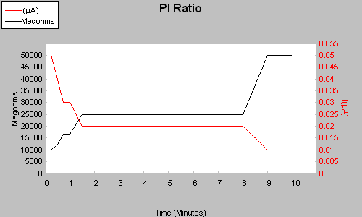

Step-Voltage | Motor ID CH-1
Test Date/Time | 6/6/2016 11:33:58 AM
DC Status | PASS

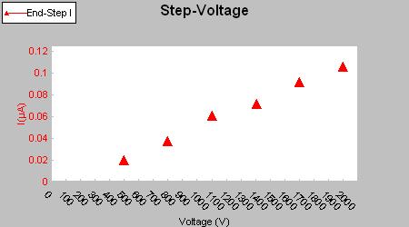

Step Length (Sec) | Volts (V) | I(µA) | Megohms | IR@40C
60 | 500 | 0.02 | 25515 | 8352
60 | 800 | 0.04 | 21340 | 6985
60 | 1100 | 0.06 | 18184 | 5952
60 | 1410 | 0.07 | 19780 | 6474
60 | 1700 | 0.09 | 18590 | 6085
60 | 2000 | 0.11 | 18931 | 6196

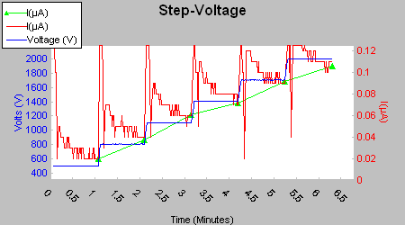

Surge: Nested Waveforms |  | Motor ID CH-1
Test Date/Time | 6/6/2016 12:03:11 PM | Surge Status | ppEAR LIMIT

Lead | Peak Voltage (V) | PP EAR Status | Max P-P EAR(%)
1 | 530 | FAIL | 16.7
2 | 740 | FAIL | 5.1
3 | 530 | FAIL | 6.1

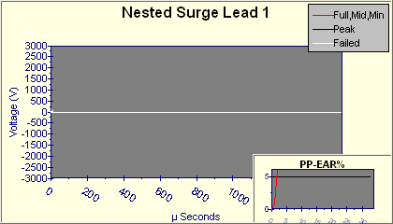
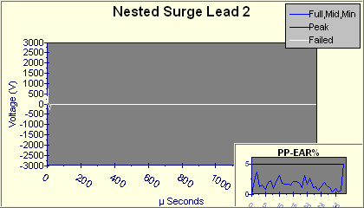
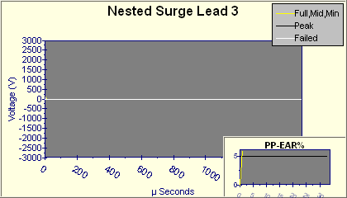

Pulse-to-Pulse EAR |  | Motor ID CH-1
Test Date/Time | 6/6/2016 12:03:11 PM | Surge Status | ppEAR LIMIT

Lead | Peak Voltage (V) | PP EAR Status | Max P-P EAR(%)
1 | 530 | FAIL | 16.7
2 | 740 | FAIL | 5.1
3 | 530 | FAIL | 6.1

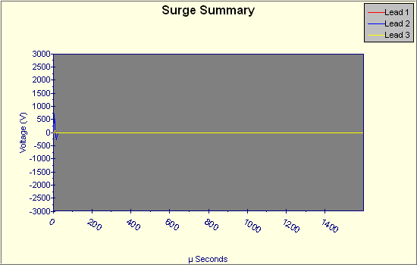
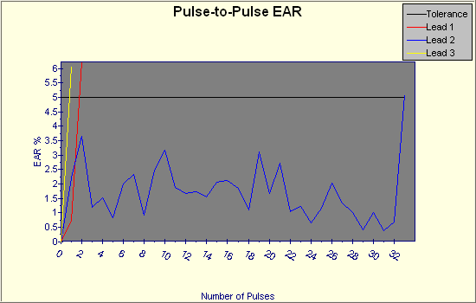

Surge Phase-to-Phase Comparison |  | Motor ID CH-1
Test Date/Time | 6/6/2016 12:03:11 PM | Surge Status | ppEAR LIMIT

Compare | Peak Voltage (V) | LL EAR Status | L-L EAR%
1 - 2 | 530 | No Test | 75
2 - 3 | 740 | No Test | 90
3 - 1 | 530 | No Test | 24

